LAB 8 REPORT

NAME: FONG WEI TZE

STUDENT ID: 22030274

**PART A: Packet Tracer - Investigate the TCP/IP and OSI Models in Action**

**Step 1: Switch from Realtime to Simulation mode.**

**Step 2: Generate web (HTTP) traffic.**

**Step 3: Explore the contents of the HTTP packet.**

**What information is listed in the numbered steps directly below the In Layers and Out Layers boxes for Layer 7?**

HTTP for the out layer, no information for the in layer.

**What is the Dst Port value for Layer 4 under the Out Layers column?**

80

**What is the Dest. IP value for Layer 3 under the Out Layers column?**

192.168.1.254

**What is the common information listed under the IP section of PDU Details as compared to the information listed under the OSI Model tab? With which layer is it associated?**

The common information listed under the IP section of PDU details compared to the information listed under the OSI model tab is the source IP address and destination IP address. The layer which is associated is layer 3.

**What is the common information listed under the TCP section of PDU Details, as compared to the information listed under the OSI Model tab, and with which layer is it associated?**

The common information listed under the TCP section of the PDU details compared to the information listed under the OSI model tab is the source port and destination port.

**What is the Host listed under the HTTP section of the PDU Details? What layer would this information be associated with under the OSI Model tab?**

**Part 2: Display Elements of the TCP/IP Protocol Suite**

**What additional Event Types are displayed?**

TCP,DNS,ARP

**What information is listed in the NAME field: in the DNS QUERY section?**

[**www.osi.local**](http://www.osi.local)

**At which device was the PDU captured?**

Web client

**What is the value listed next to ADDRESS: in the DNS ANSWER section of the Inbound PDU Details?**

4

**Find the first HTTP event in the list and click the colored square box of the TCP event immediately**

**following this event. Highlight Layer 4 in the OSI Model tab.**

**Click the last TCP event. Highlight Layer 4 in the OSI Model tab. Examine the steps listed directly below In Layers and Out Layers.**

**What is the purpose of this event, based on the information provided in the last item in the list (should be item 4)?**

The device sets the connection state to closed as the data transfer process between the web server and the web client has been accomplished.

**Based on the information that was inspected during the Packet Tracer capture, what port number is the Web Server listening on for the web request? What port is the Web Server listening on for a DNS request?**

Port 53

**PART B: Packet Tracer - Physical Layer Exploration - Physical Mode**

**Part 1: Examine Local IP Addressing Information**

**What is the IPv4 address and default gateway for your device?**

**IPv4 address: 172.20.99.72**

**Default gateway:** **172.20.0.1**

**Step 2: What is the IPv4 address for my router?**

**What is the IPv4 address for your router?**

**172.20.0.1**

**Step 3: What is my public IPv4 address?**

**On your device, use one of the "what is my ip" websites you found in your search. List your public IPv4 address, location, and ISP.**

**Step 4: Examine the connections in your network.**

**What does the connection look like between your device and your router? Is it wired or wireless?**

Wireless

**Where is the router that your device uses to access the internet?**

On the ceiling

**What does the connection look like between your router and the internet? Does it use a cable from the cable company or the phone company? Is it wireless? Can you find the cable as it leaves your house or see the remote tower if it is a wireless connection?**

It uses a cable from the cable company.

**Part 2: Trace the Path Between Source and Destination**

**Step 1: Use traceroute to display the path from Monterey to Hawaii.**

**Step 2: Investigate the second hop in the traceroute output.**

**In your own network, what is the technology for the local loop you are using? Cable? DSL? Satellite? Cellular? If it is a wired connection, see if you can find the cable leaving your home network. Where does it go? To a telephone pole? Underground?**

The technology for the local loop is cable and the cable leaving the home goes to the underground.

**The second hop in your traceroute command on your device is typically your ISP's POP. What is the IP address for your ISP's POP?**

172.16.16.1

**Step 3: Attempt to discover the physical location of the IP address for your ISP POP.**

**Who owns the POP for the second router in your traceroute output?**

Unknown

|  |  |
| --- | --- |
| **2nd hop IPv4 address** | **172.16.16.1** |
| **ISP** | **Sunway University** |
| **City** | **Shah Alam** |
| **Region** | **Selangor** |
| **Country** | **Malaysia** |

**Step 5: Investigate the local ISP network.**

**What is the IPv4 address of the 3rd hop in the Packet Tracer traceroute output?**

10.110.178.133

**Which router and interface in the monterey.ca building is configured with this IPv4 address?**

Rur02.monterey.ca.sfba.comcast.net, GigabitEthernet0/0.

**What is the IPv4 address of the 4th hop in the Packet Tracer traceroute output?**

10.139.198.129

**Which router and interface in the monterey.ca building is configured with this IPv4 address?**

Rur01.monterey.ca.sfba.comcast.net, GigabitEthernet0/0.

**Why do you think the IP addresses for the other interfaces are not shown in the traceroute output?**

**It could be due to the settings of the router or the firewall which prevents tracing to the network.**

**List the hops in your own traceroute output that belong to your local ISP.**

**Step 6: Investigate the domain names in the output to discover more clues about the location of**

**routers at each hop**

**What information, if any, can you decipher from the domain names for your local ISP?**

**Navigate up one level to Intercity. (Packet Tracer does not allow the renaming of Intercity.) You will see a representation of the physical links between the home in Monterey and Oahu island where the server for the University of Hawaii is located in Honolulu. Notice that the link first goes from Monterey to San Jose, and then Los Angeles before it crosses the Pacific Ocean to Honolulu**

**Click San Jose. Notice there are three buildings, each labeled with a part of the domain name discovered in the traceroute output. Routers with the same domain name are located in the same building. Investigate each building, router, and interface to complete the following table.**

|  |  |  |  |
| --- | --- | --- | --- |
| Hop | Domain name | Interface | IPv4 Address |
| 5 | be-222-rar01.santaclara.ca.sfba.comcast.net | GigabitEthernet0/0 | 10.151.78.177 |
| 6 | be-39931-cs03.sunnyvale.ca.ibone.comcast.net | GigabitEthernet0/0 | 10.110.41.121 |
| 7 | be-1312-cr12.sunnyvale.ca.ibone.comcast.net | GigabitEthernet0/0 | 10.110.46.30 |
| 8 | be-303-cr01.9greatoaks.ca.ibone.comcast.net | GigabitEthernet0/0 | 10.110.37.178 |
| 9 | be-2211-pe11.9greatoaks.ca.ibone.comcast.net | GigabitEthernet0/0 | 10.110.32.246 |

**What is the building, router, interface, and IPv4 address for the outbound link to Los Angeles?**

Building: Greatoaks.calibone

Router: rtsw.sunn.net.internet2.edu

Interface: GigabitEthernet0/0

IPv4 address: 172.16.69.141

**Step 7: Investigate the link between Comcast and Internet2.**

**In Packet Tracer, navigate to San Jose, if necessary, and then click the 9greatoaks.ca building. Notice the name of the third router in the rack indicates that it belongs to Internet2. This router is the 10th hop in the traceroute output.**

**What is the interface for the 10th hop?**

GigabitEthernet0/0

**Step 9: Investigate the link to Los Angeles.**

**In Packet Tracer, navigate to the Intercity level, and then click Los Angles.**

**The losa.net.internet2.edu building is located somewhere in Los Angeles County. Click the building to enter it.**

**What is the interface used for this 11th hop in the traceroute output?**

GigabitEthernet0/0

**Step 10: Investigate the link across the Pacific Ocean.**

**Search the internet for "submarine cable map" and see if you can locate any submarine cables that have a landing point both in Hermosa Beach and Hawaii. How many submarine cables terminate at Hermosa Beach?**

3 submarine cables terminate at Hermosa Beach

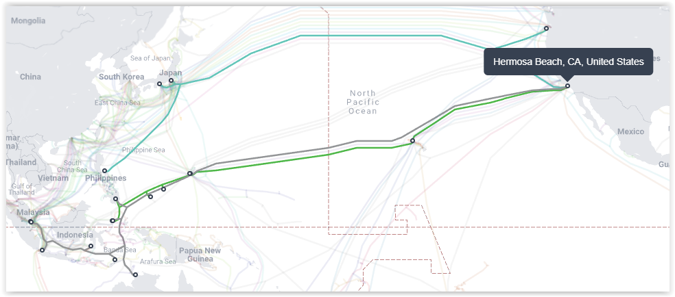

**What is the name of the submarine cable that runs from Hermosa Beach to Hawaii?**

SEA US

**What is the name of the landing point in Hawaii?**

Makaha Cable Landing Station

**How many submarine cables terminate at this landing point in Hawaii?**

4

**In Packet Tracer, navigate to the Intercity level. Follow the cable across the Pacific Ocean. Two**

**repeaters are shown here although there would be more dozens more.**

**Search the internet to find how many kilometers separate each repeater on a submarine cable.**

Typically from 40 to 90km

**Click the i2px-Hawaii building. In the rack are two routers. The first one belongs to I2PX and represents the 12th hop in the traceroute output.**

**What interface is assigned to the 12th hop?**

GigabitEthernet0/0

**Step 12: Investigate the last known IP address in the traceroute output.**

I am unable to trace the last known IP address based on the traceroute output. This is most likely due to the settings of the router or firewall which blocks any further traceroutes messages from entering the network prior to reaching the web server.

